My Blog, My Philippines
In Pictures – Part IV/A
By Alex Moises / Philippines, 2011-2012 Version / Dedicated to Gabby Moises
<People (PE), Places (PL), Nature (N), Animals (A), And Then Some (S) /
(Photo Arrangement - Left to Right, Top to Bottom for Each Page)

Topic Highlight - People (PE)
Philippine Heroes and A Heroine

Andres Bonifacio

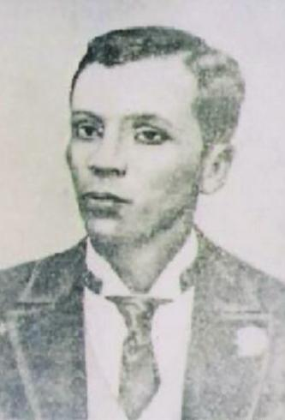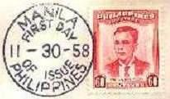
Bonifacio Portrait and Portrait of Andres Bonifacio on Main
Part of the 1958 Philippine First Day Cover

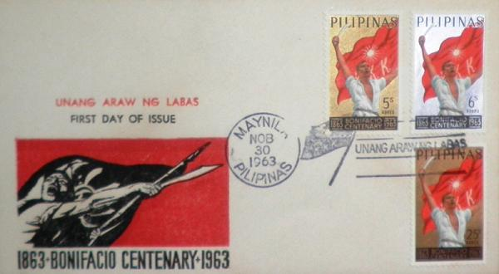
Birth Centenary of Andres Bonifacio on 1963 Philippine First Day Cover

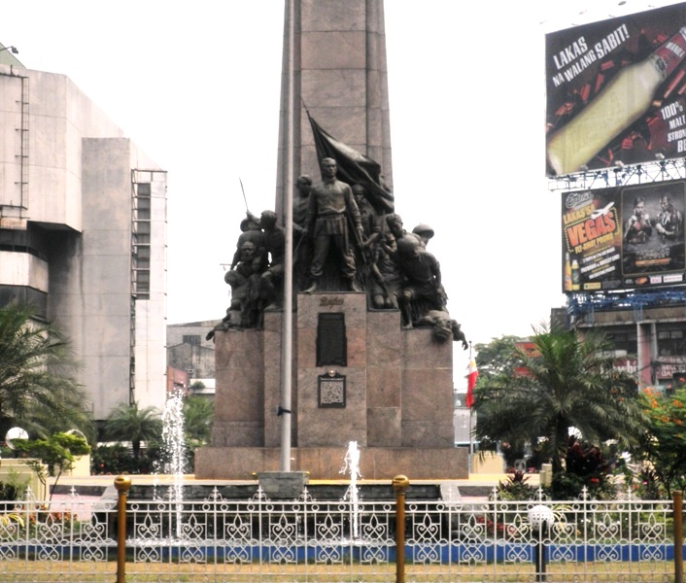
Andres Bonifacio Monument in Kalookan City

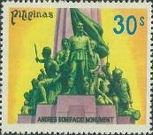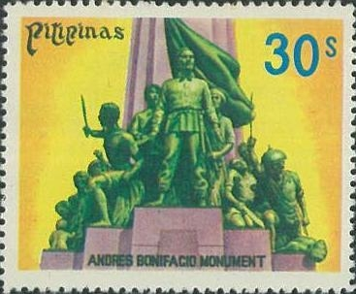
Andres Bonifacio Monument on 1978 Philippine Stamp / Shown, Regular Stamp on the Left and Enlarged Stamp on the Right

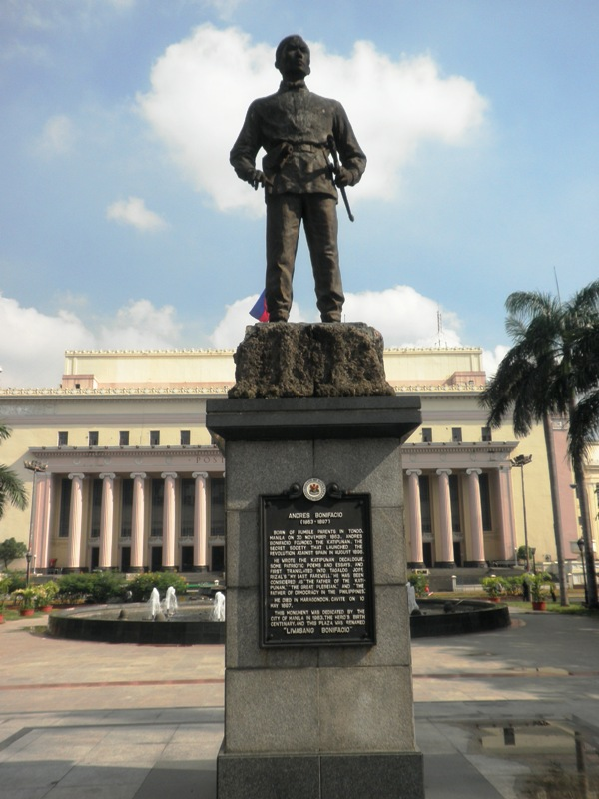
Andres Bonifacio Monument at Liwasang Bonifacio in Manila

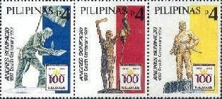
Various Andres Bonifacio Monuments on 1997 Philippine Stamps

Emilio Jacinto

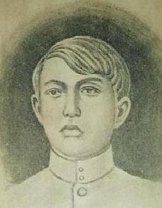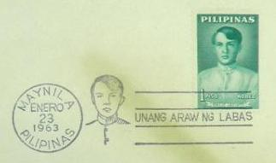
Jacinto Portrait Jacinto Portrait on FDC

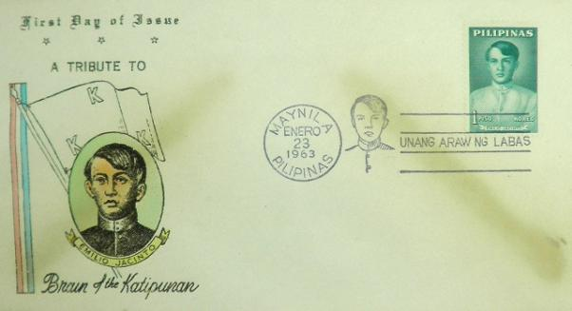
Emilio Jacinto on 1963 Philippine First Day Cover / Above, the Main Part of the First Day Cover

Graciano Lopez Jaena

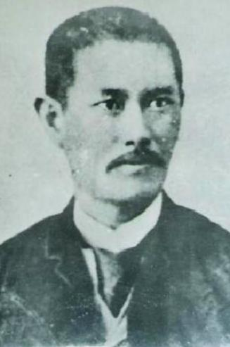
Jaena Portrait

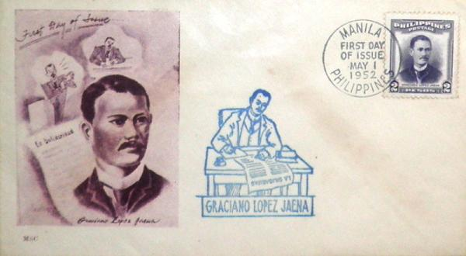
Graciano Lopez Jaena on 1952 Philippine First Day Cover

Jose Rizal

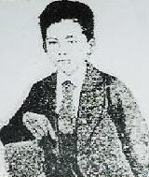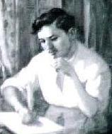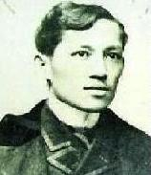
Portraits of Jose Rizal

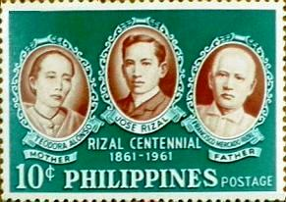
Rizal and Parents <Teodora Alonzo - Mother / Francisco Mercado Rizal - Father> on Enlarged 1961 Philippine Stamp

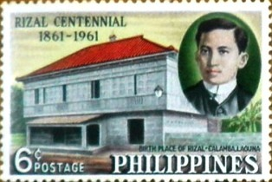
Rizal’s Ancestral House in Calamba, Laguna <Birth Place> on Enlarged 1961 Philippine Stamp

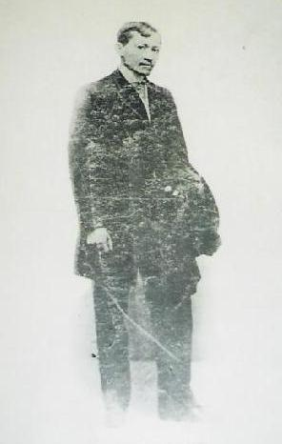
Jose Rizal

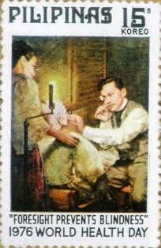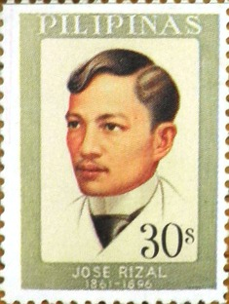
Rizal as Doctor on Enlarged 1976 and 1977 Philippine Stamps, Respectively

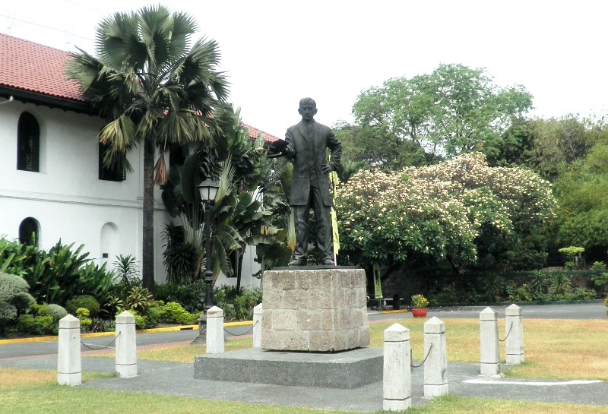
Rizal Statue and Shrine at Fort Santiago

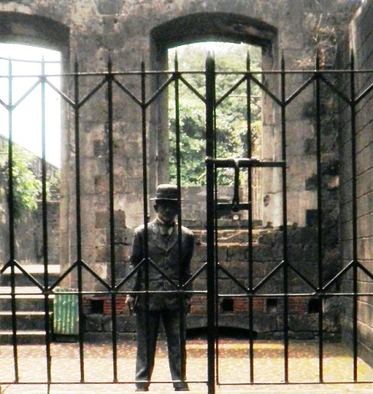
Rizal’s Effigy at Fort Santiago, Manila

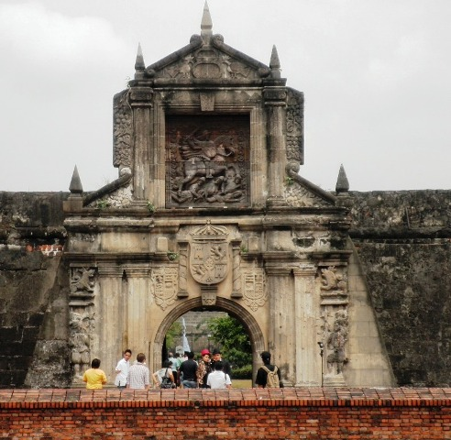
Fort Santiago, Manila

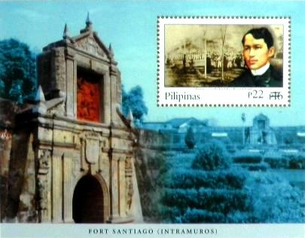
Main Part of the Enlarged 2003 Overprint Booklet Pane with Rizal Stamp

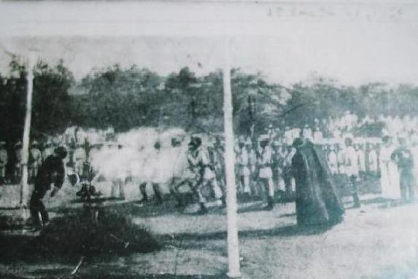
Rizal’s Execution <Martyrdom> at Bagumbayan Field <Now, Rizal Park> in 1896

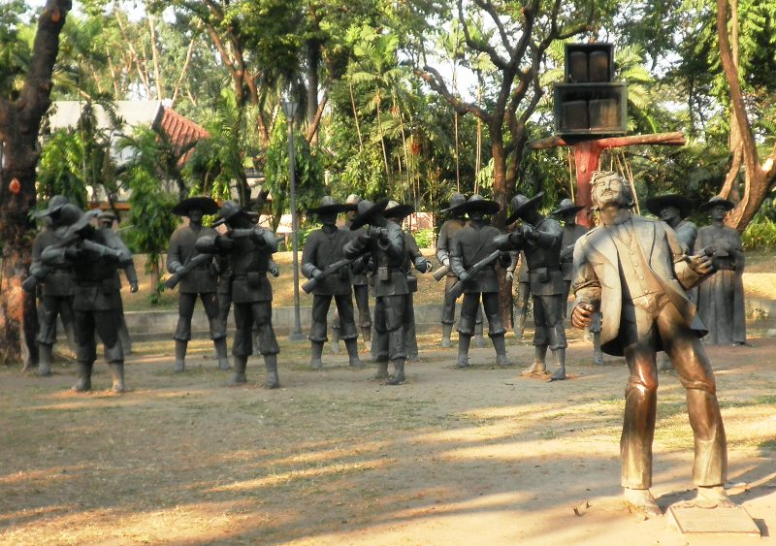
Symbolic Representation of Rizal’s Martyrdom at Rizal Park, Manila where the execution took place in 1896

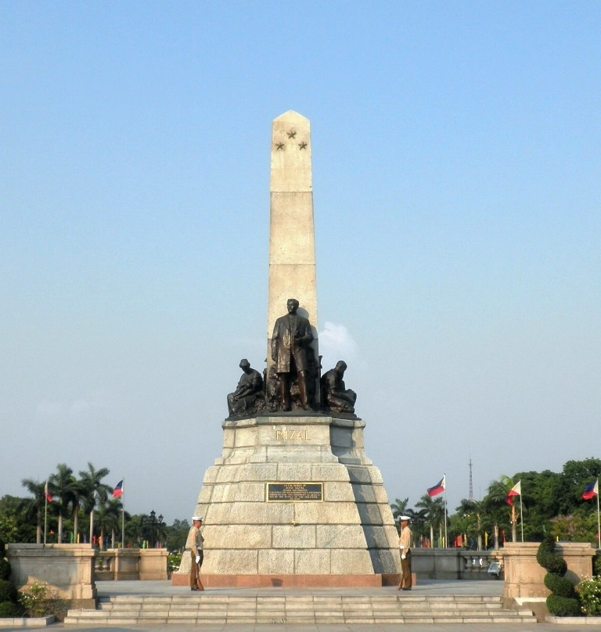
Rizal Monument, Rizal Park, Manila

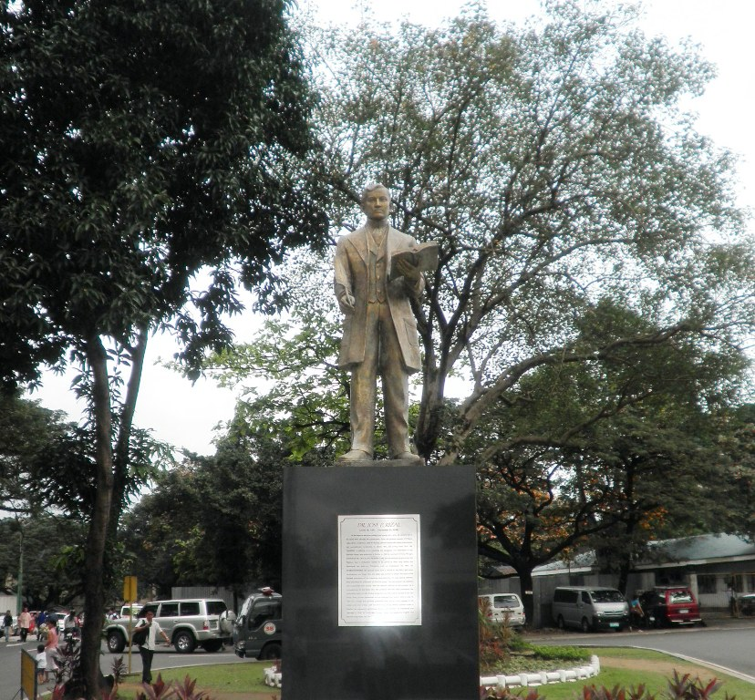
Rizal Monument, Quezon City

Lapu-Lapu

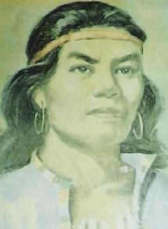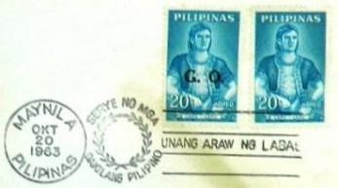
Lapu-Lapu Portrait and Lapu-Lapu on Main Part of the 1963 Philippine First Day Cover

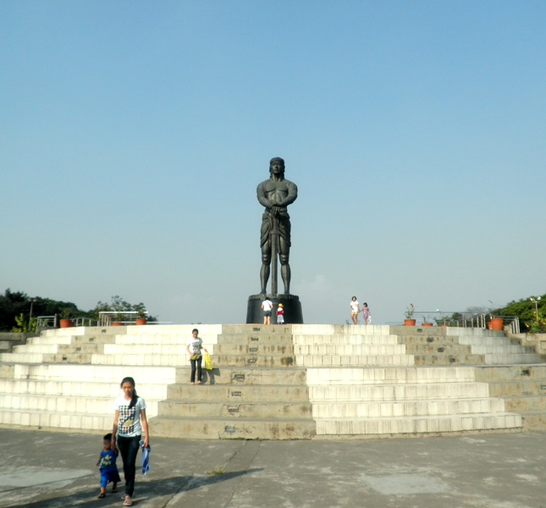
Lapu-Lapu Statue, Rizal Park, Manila

Melchora Aquino

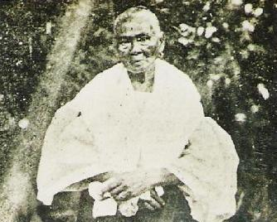
Aquino Portrait

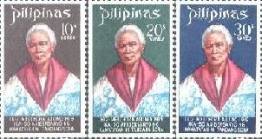
Melchora Aquino on 1969 Philippine Stamps

