My Blog, My Philippines
In Pictures – Part II
By Alex Moises / Philippines, 2010-2011 Version / Dedicated to Gabby Moises
<People (PE), Places (PL), Nature (N), Animals (A), And Then Some (S) /
(Photo Arrangement - Left to Right, Top to Bottom for Each Page)

People (PE) - Filipinos

Alex Moises, Aquilino Pimentel, Jr., Bellaflor Angara-Castillo and Fidel Ramos
(Photo Contributors: Pimentel’s Photo, Courtesy of Keith Bacongco via Wikipedia’s Creative Commons / Ramos’s Picture, Photo in the Public Domain, Courtesy of the US Defense Department)

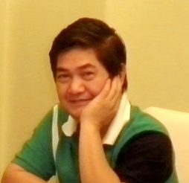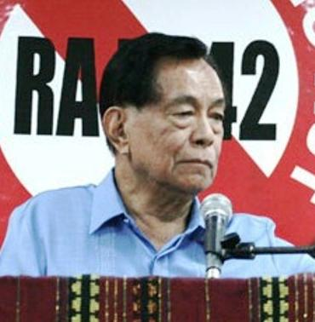

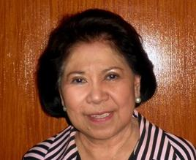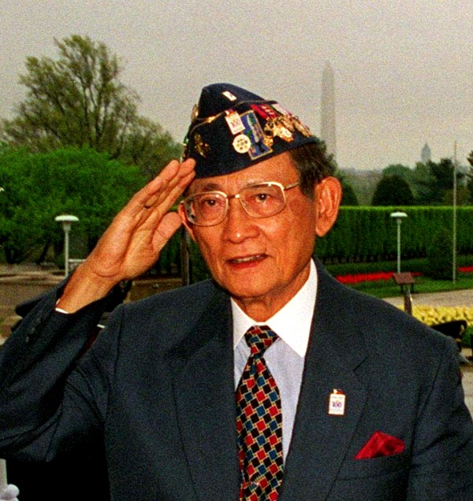

Gloria Macapagal-Arroyo, Jose Diokno, Leticia Moises and Richard Gordon
(Photo Contributors: Arroyo’s Photo in the Public Domain, Courtesy of the US Defense Department / Diokno’s Photo in the Public Domain, Courtesy of Diokno.Org / Gordon’s Picture, Photo in the Public Domain, Courtesy of Francis via Wikipedia)

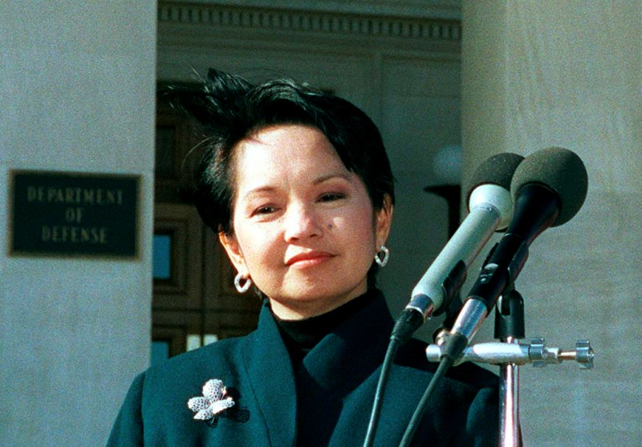

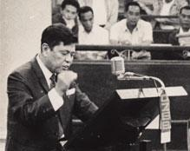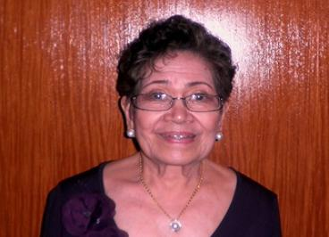

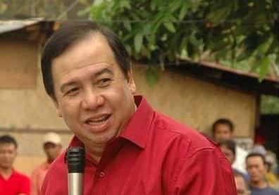

Places (PL) - Metro Manila and Subic

Metro Manila
(Locations: Rizal Monument, Rizal Park, Manila <First Two Photos> / Rizal Park along Roxas Boulevard and the Manila Hotel, Manila / Fort Santiago, Manila <Bottom Two Photos>)

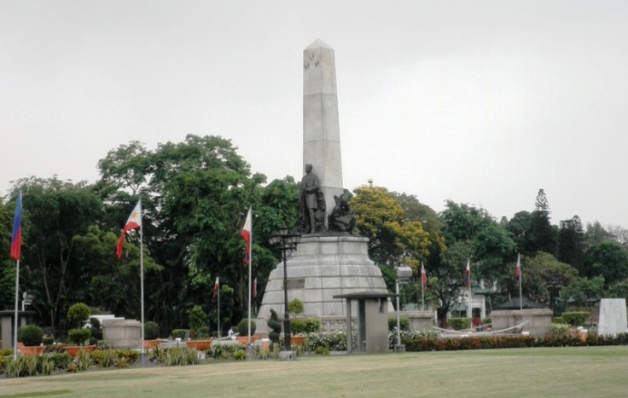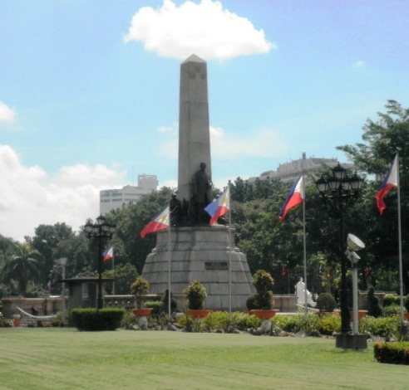

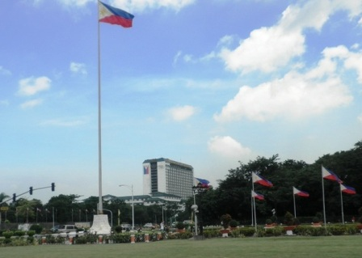

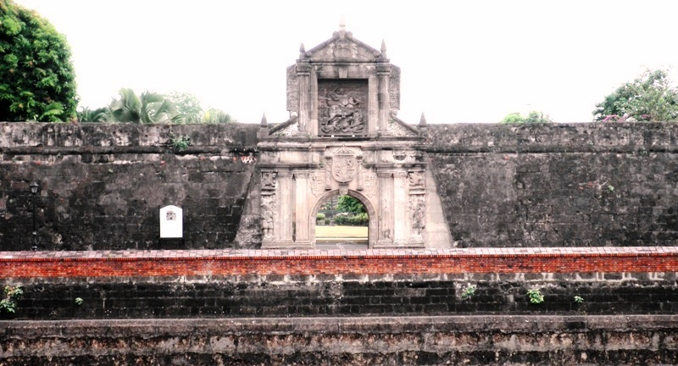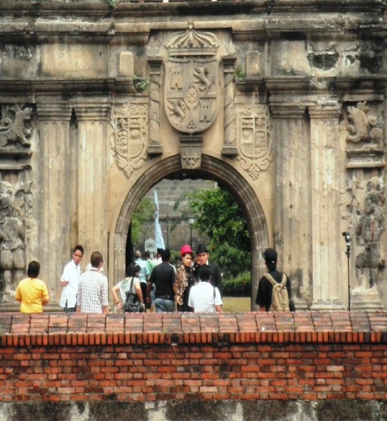

Metro Manila
(Locations: Quezon Memorial Tower and Shrine, Quezon City <Top Two Photos> / Andres Bonifacio Monument, Kalookan <Bottom Two Photos>)

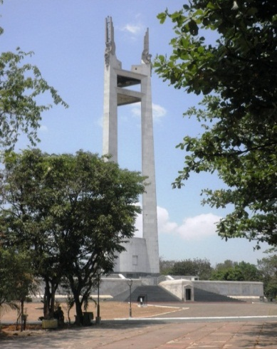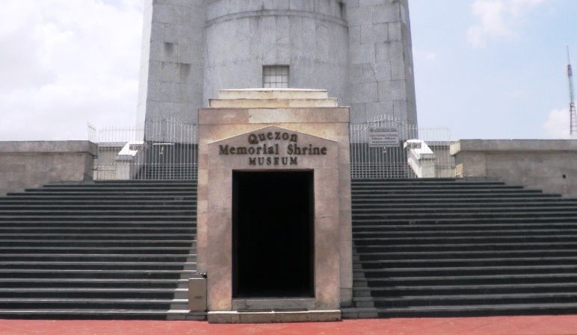

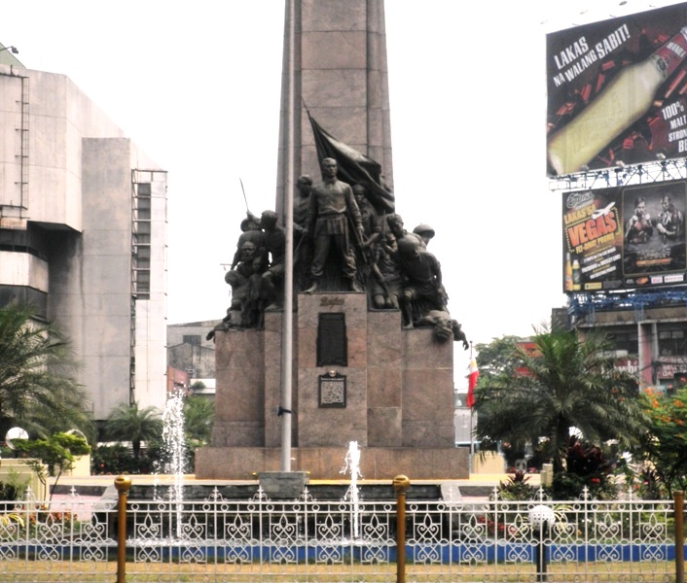

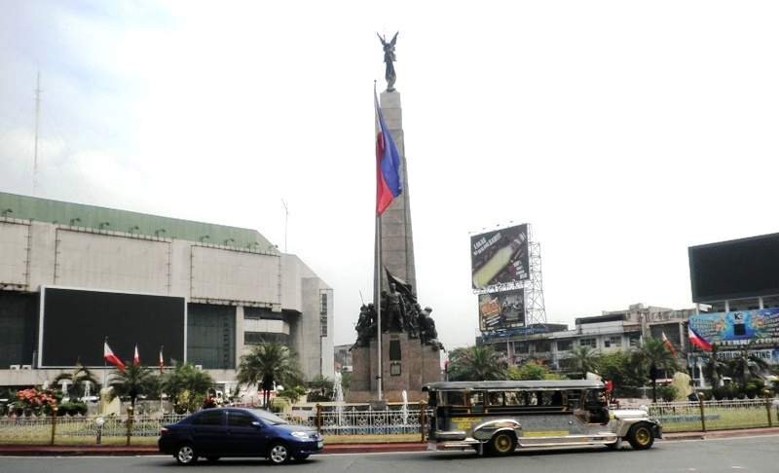

Metro Manila
(Locations: Ortigas Skyline, Mandaluyong and San Juan Cities / Club Filipino, San Juan / Zamboanga Restaurant, Manila / Araneta Coliseum, Araneta Center, Quezon City)

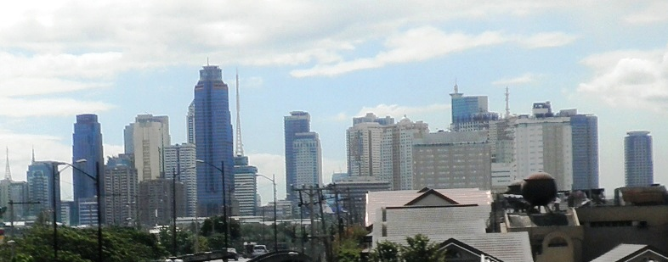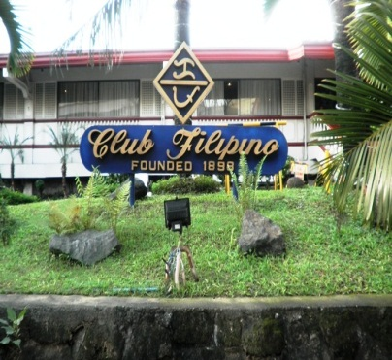

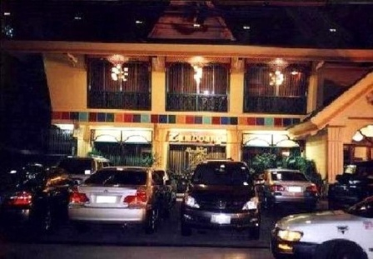

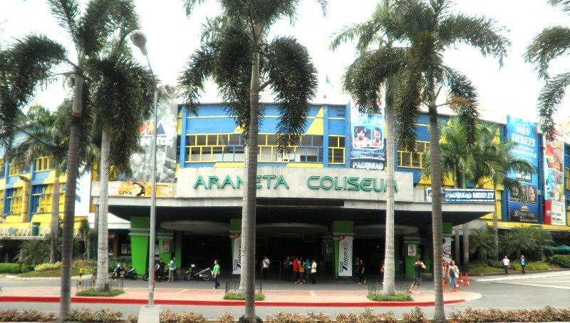

Metro Manila
(Locations: Eastwood Mall, Quezon City / SM Mall of Asia, Pasay / Manila Bay Area Skyline at Night, Manila)

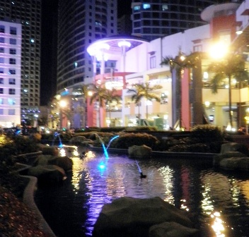

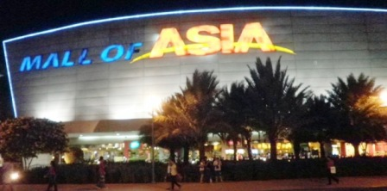

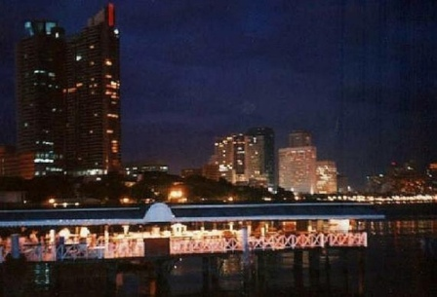

Subic Bay Freeport
(Locations: SBMA Office and Inang Laya Monument <First Two Photos> / All in the Waterfront Area)

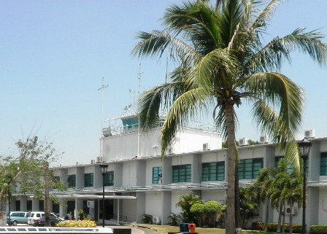

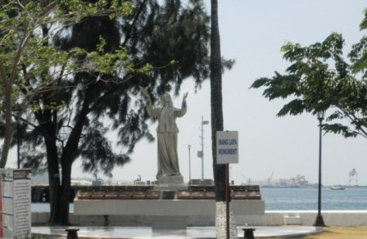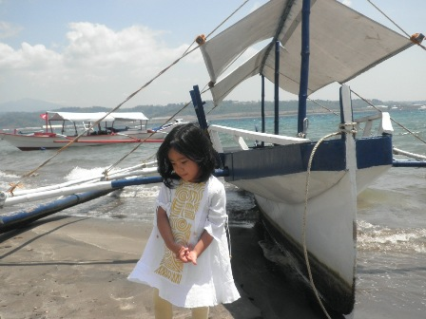

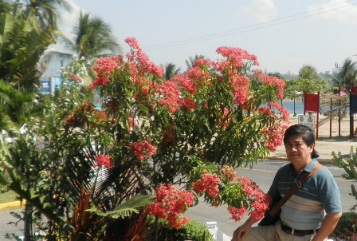

Subic Bay Freeport
(Locations: Yacht Club / Subic Bay Gateway Park / Aristocrat Restaurant / Other Business Establishments - All Along Rizal Highway)

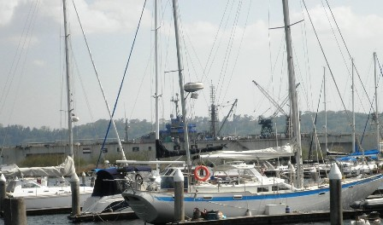

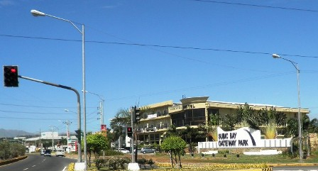

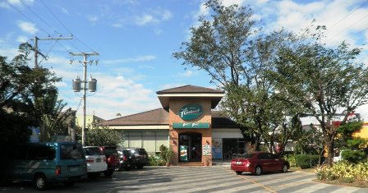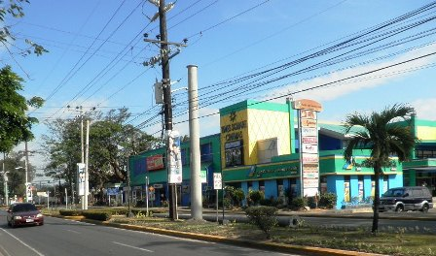

Nature (N) - Philippine Sceneries and Flowers

Sceneries
(Locations: Seashore and Mountain Range, Aurora Province / Rice Field, Pampanga Province / Mountain Range and Rice Field, Zambales)

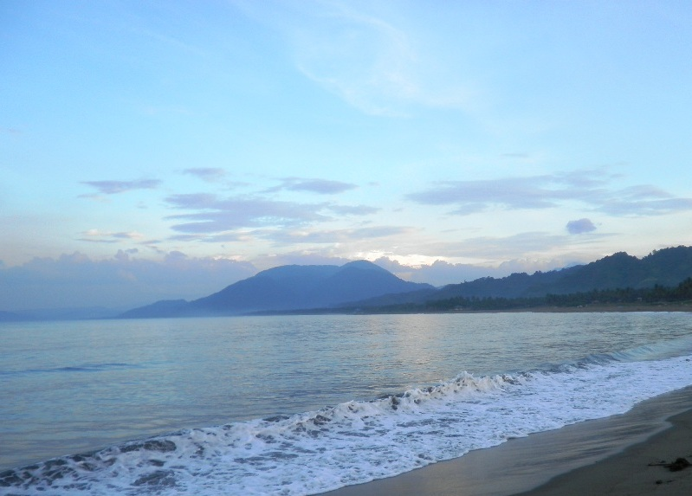

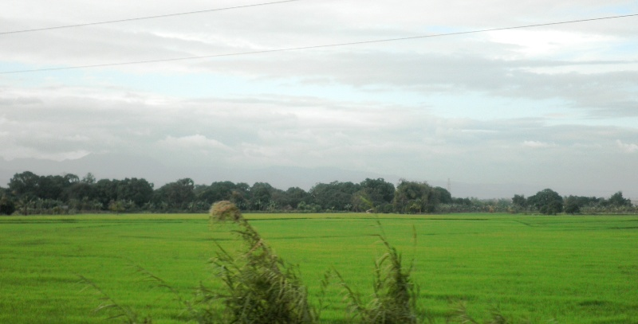

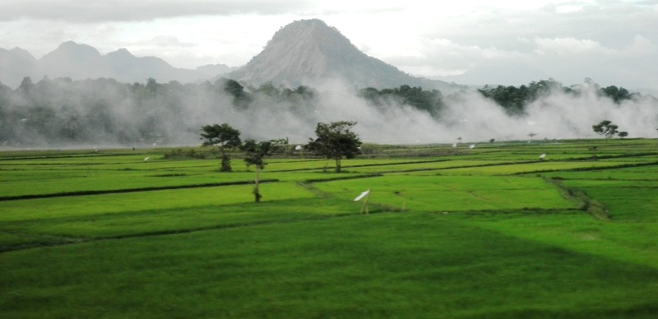

Flowers

Bird of Paradise

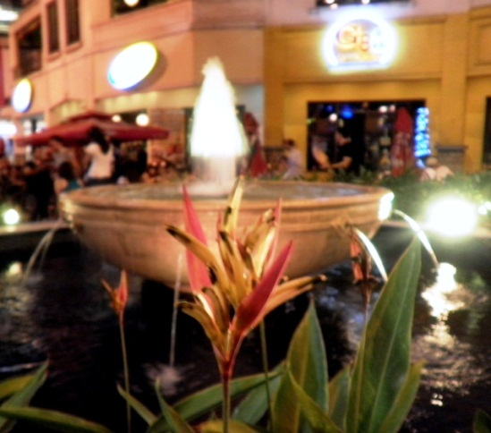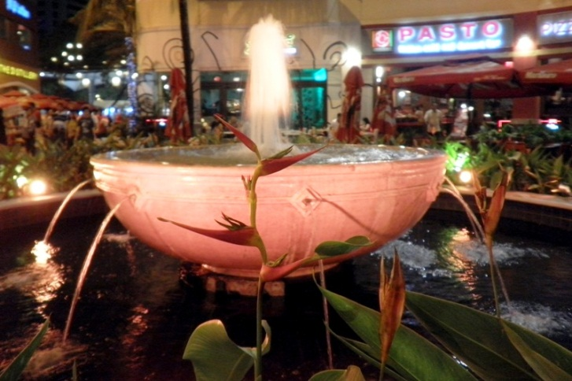

Bougainvillea

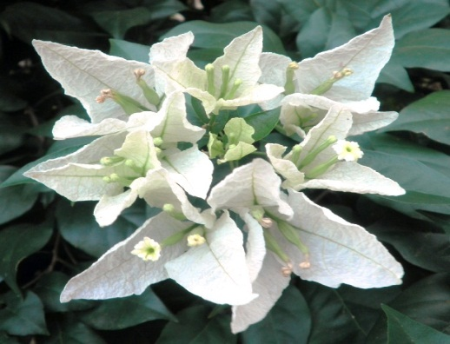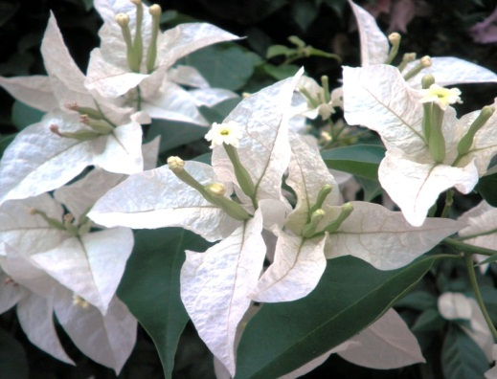

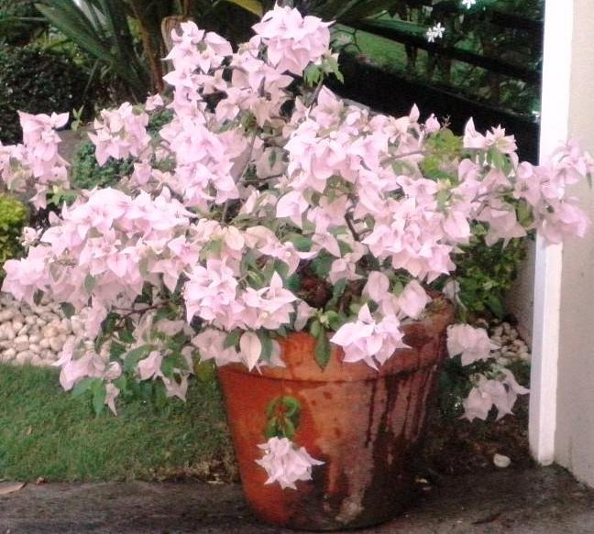

Flowers

Dona Luz
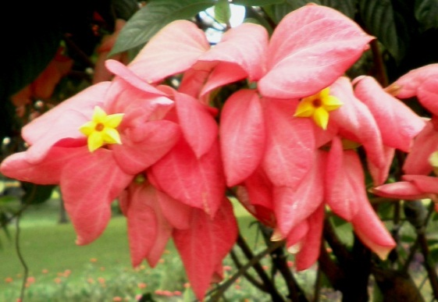  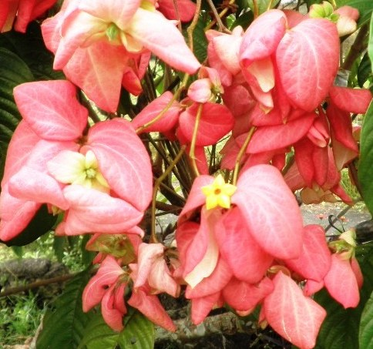 | 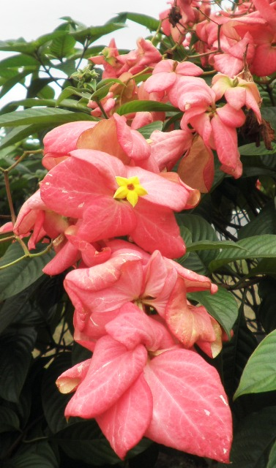

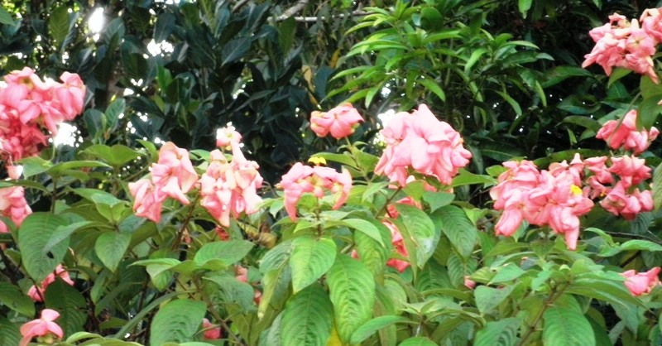

Animals (A) - Philippine Animals

Brahminy Kite

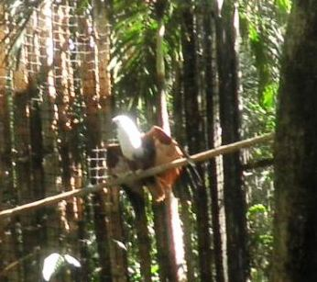

Long-Tailed Macaque

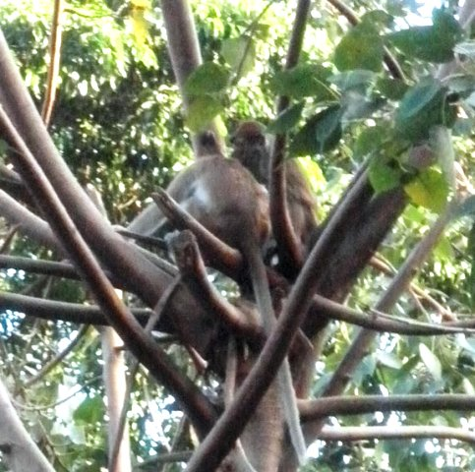

Philippine Crocodile

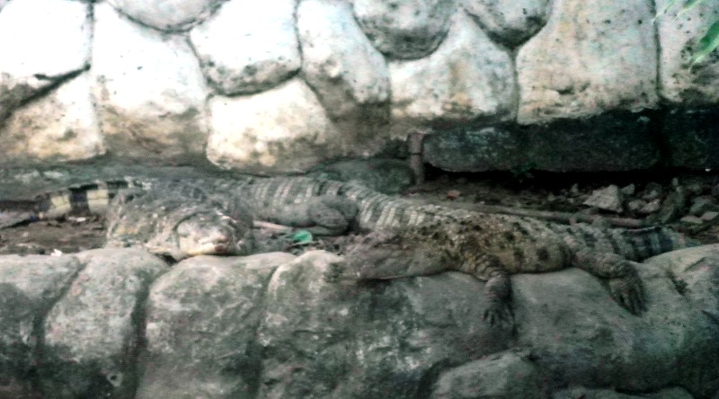

And Then Some (S) - National Commemoration and Celebration

All Saints’ Day and All Souls’ Day Commemoration

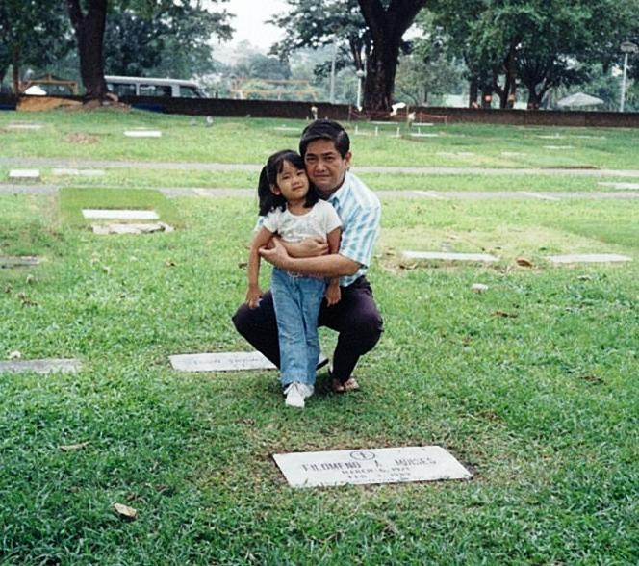

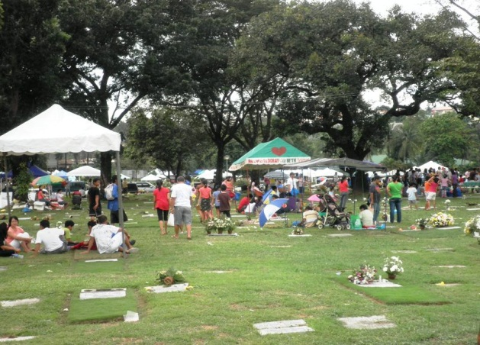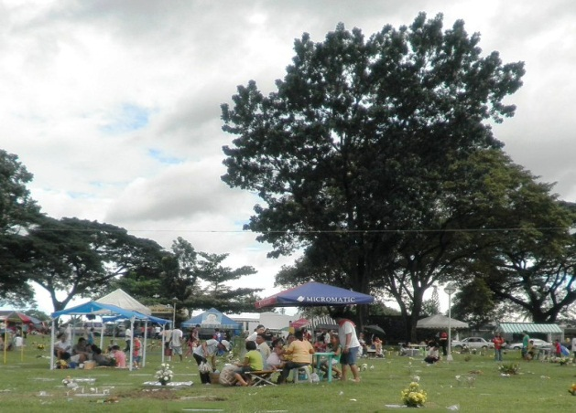

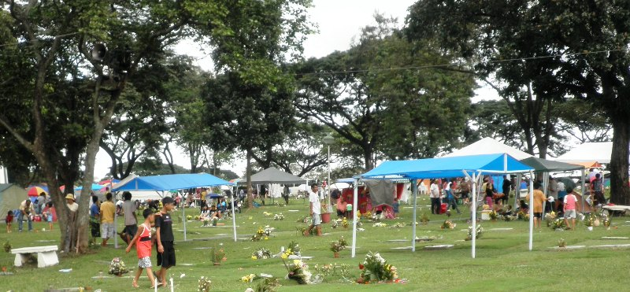

Christmas Celebration

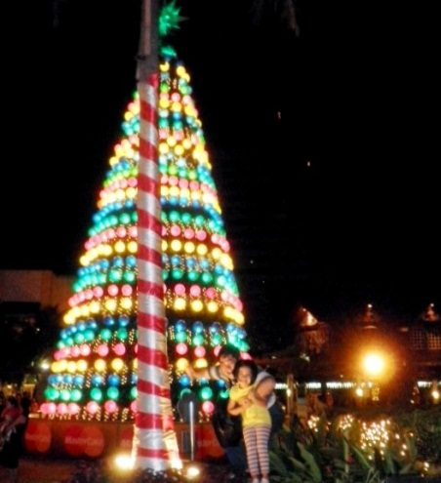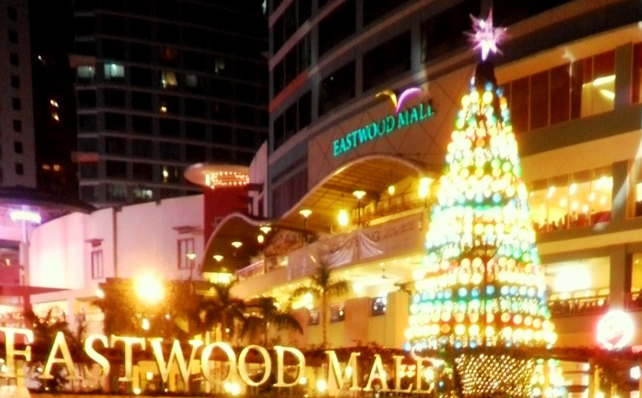

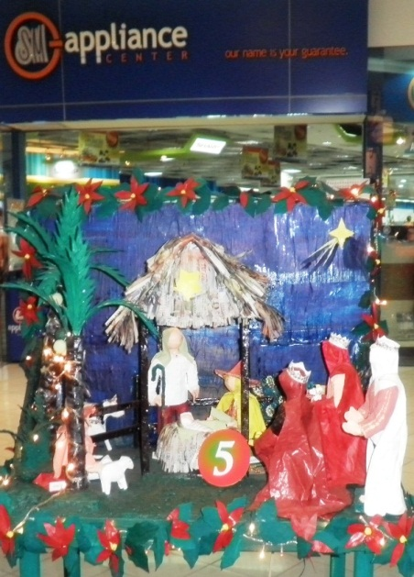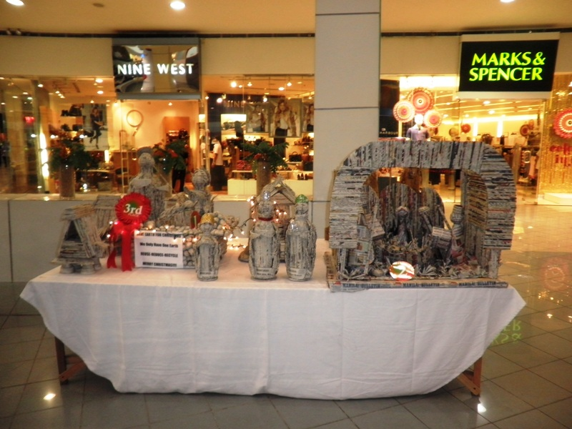

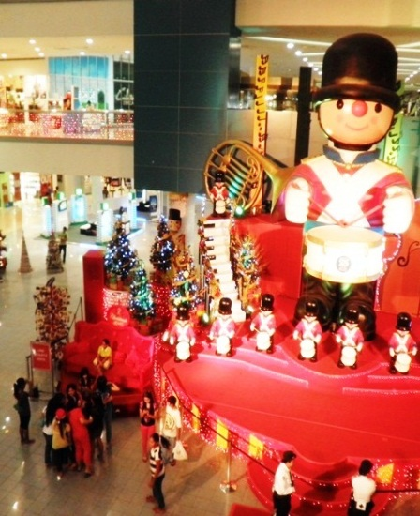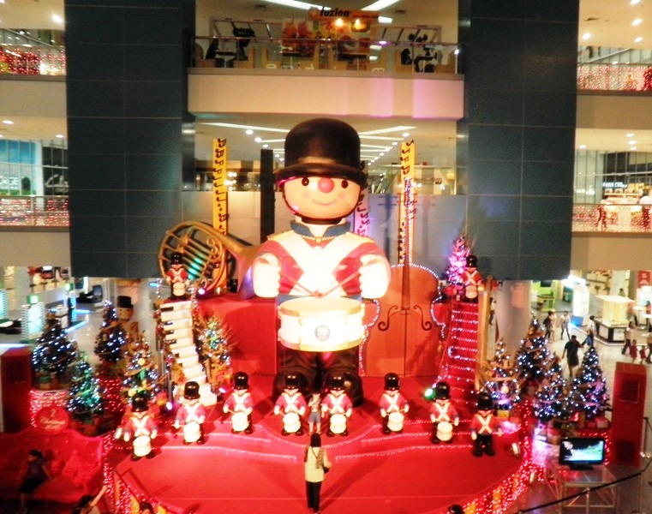

Christmas Celebration

